SESSION 12:

Task 1:
use mydb;
create table SpotifyArtists
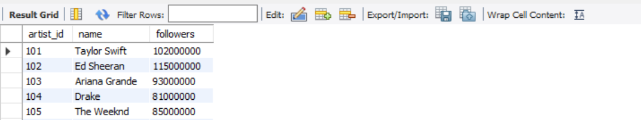
(artist_id INT PRIMARY KEY,
name VARCHAR(255) NOT NULL,
followers INT NOT NULL);

select * from spotifyartists;

Insert into Spotifyartists
values (101, 'Taylor Swift', 102000000),
(102, 'Ed Sheeran', 115000000),
(103, 'Ariana Grande', 93000000),
(104, 'Drake', 81000000),
(105, 'The Weeknd', 85000000),
(106, 'Billie Eilish', 88000000);


WITH TopArtists AS (
SELECT
artist_id,
name,
followers
FROM
SpotifyArtists
ORDER BY
followers DESC
LIMIT 3
)
SELECT
artist_id,
name,
followers
FROM
TopArtists;
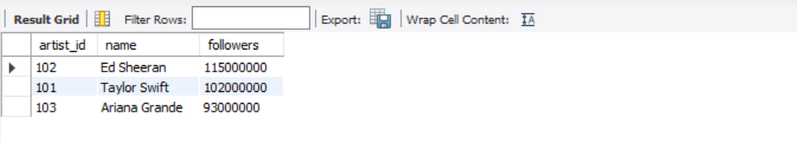

TASK 2:

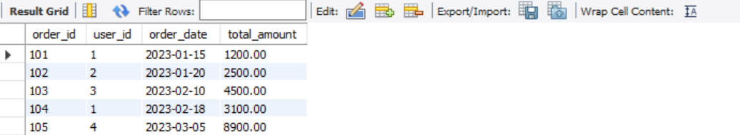
use mydb;
CREATE TABLE FlipkartOrders (
order_id INT PRIMARY KEY,
user_id INT,
order_date DATE,
total_amount DECIMAL(10, 2)
);
select * from flipkartorders;
-- Insert Sample Data for 2023
INSERT INTO FlipkartOrders (order_id, user_id, order_date, total_amount) VALUES
(101, 1, '2023-01-15', 1200.00),
(102, 2, '2023-01-20', 2500.00),
(103, 3, '2023-02-10', 4500.00),
(104, 1, '2023-02-18', 3100.00),
(105, 4, '2023-03-05', 8900.00), -- Highest Month (March: 8900 + 1200 = 10100)
(106, 2, '2023-03-22', 1200.00),
(107, 5, '2023-04-12', 3400.00),
(108, 3, '2023-05-01', 5600.00),
(109, 2, '2023-11-11', 7800.00),
(110, 4, '2023-12-25', 4300.00);

WITH MonthlyTotals AS (
SELECT
EXTRACT(MONTH FROM order_date) AS order_month,
SUM(total_amount) AS total_sales
FROM
FlipkartOrders
WHERE
EXTRACT(YEAR FROM order_date) = 2023
GROUP BY
EXTRACT(MONTH FROM order_date)
)
SELECT
order_month,
total_sales
FROM
MonthlyTotals
ORDER BY
total_sales DESC
LIMIT 1;
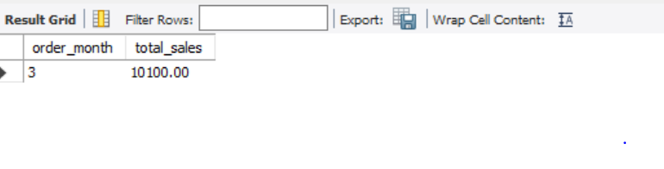
TASK 3:
Create the CalendarDays table structure C
REATE TABLE CalendarDays ( id SERIAL PRIMARY KEY, day_date DATE NOT NULL ); --
Populate the CalendarDays table using the recursive CTE
INSERT INTO CalendarDays (day_date) WITH RECURSIVE DateGenerator AS ( SELECT CURRENT_DATE AS day_date, 1 AS level UNION ALL SELECT (day_date + INTERVAL '1 day')::DATE, level + 1 FROM DateGenerator WHERE level < 7 )
SELECT day_date FROM DateGenerator; -- Verify the dataset SELECT * FROM CalendarDays;
WITH RECURSIVE CalendarDays AS ( -- Anchor member: Starts with the current date SELECT CURRENT_DATE AS day_date, 1 AS level
UNION ALL –
Recursive member: Adds 1 day until reaching 7 days total SELECT (day_date + INTERVAL '1 day')::DATE, level + 1 FROM CalendarDays WHERE level < 7 ) –
Select the generated dates from the CTE SELECT day_date FROM CalendarDays;

TASK 4:
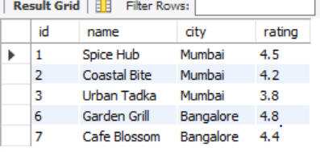

use mydb;  
Select * from Zomatorestaurants;
CREATE TABLE ZomatoRestaurants (
id INT PRIMARY KEY,
name VARCHAR(100),
city VARCHAR(50),
rating DECIMAL(2, 1));
-- Step 2: Insert Sample Data
INSERT INTO ZomatoRestaurants (id, name, city, rating) VALUES
(1, 'Spice Hub', 'Mumbai', 4.5),
(2, 'Coastal Bite', 'Mumbai', 4.2),
(3, 'Urban Tadka', 'Mumbai', 3.8),
(4, 'Delhi Bistro', 'Delhi', 3.9),
(5, 'Royal Curry', 'Delhi', 3.5),
(6, 'Garden Grill', 'Bangalore', 4.8),
(7, 'Cafe Blossom', 'Bangalore', 4.4);

Select * from Zomatorestaurants;

WITH CityAvgRating AS (
SELECT
city,
AVG(rating) AS avg_city_rating
FROM ZomatoRestaurants
GROUP BY city
HAVING AVG(rating) > 4.0)
SELECT
r.id,
r.name,
r.city,
r.rating
FROM ZomatoRestaurants r
JOIN CityAvgRating c ON r.city = c.city;

TASK 5:

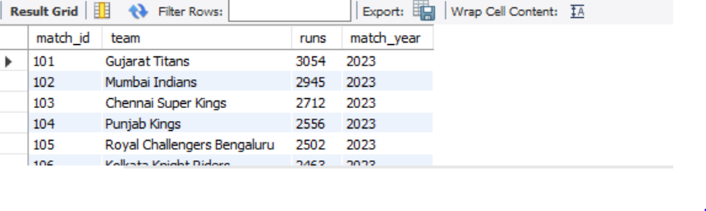
Use mydb;
Select * from IPLMatches;
CREATE TABLE IPLMatches (
match_id INT,
team VARCHAR(50),
runs INT,
match_year INT
);
-- 2. Insert sample aggregations / total runs for IPL 2023 season
INSERT INTO IPLMatches (match_id, team, runs, match_year) VALUES
(101, 'Gujarat Titans', 3054, 2023),
(102, 'Mumbai Indians', 2945, 2023),
(103, 'Chennai Super Kings', 2712, 2023),
(104, 'Punjab Kings', 2556, 2023),
(105, 'Royal Challengers Bengaluru', 2502, 2023),
(106, 'Kolkata Knight Riders', 2463, 2023),
(107, 'Rajasthan Royals', 2419, 2023),
(108, 'Sunrisers Hyderabad', 2376, 2023),
(109, 'Lucknow Super Giants', 2354, 2023),
(110, 'Delhi Capitals', 2182, 2023);

Select * from IPLMatches;

WITH TeamRuns2023 AS (
SELECT
team,
SUM(runs) AS total_runs
FROM
IPLMatches
WHERE
match_year = 2023
GROUP BY
team
)
SELECT
team,
total_runs
FROM
TeamRuns2023
WHERE
total_runs > 2000
ORDER BY
total_runs DESC;
